# C++ 2D Array Problems (C++ Lab Practice)

# C++ Double Dimension Array Problems

**Instructions:**

- Answer all questions.

- Write clear and commented code where necessary.

- Duration: 2 hours.

## Problem 1: Submatrix with Minimum Sum

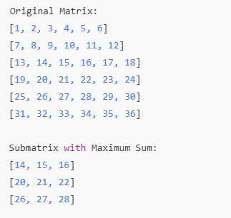Create a program to:  
1. Define a 2D array `matrix` of size NxM.  
2. Identify the 3x3 submatrix within the larger matrix that has the maximum sum of its elements.  
3. Print the original matrix, the identified submatrix, and the maximum sum.  
  
Write a `main()` function to:  
1. Input a 6x6 matrix.  
2. Calculate the submatrix with the maximum sum and display it.

## Problem 2: Row and Column Swapping

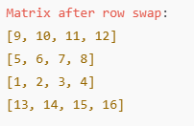Create a class `MatrixOperations` with:  
1. A private attribute `int mat[N][M]`.  
2. Methods:   
 - `setMatrix()` to input the elements of the matrix.  
 - `swapRows(int row1, int row2)` to swap two rows of the matrix.  
 - `swapColumns(int col1, int col2)` to swap two columns of the matrix.   
 - `displayMatrix()` to display the matrix.  
  
Write a `main()` function to:  
1. Create a `MatrixOperations` object.  
2. Input a 4x4 matrix, perform row and column swaps as specified by the user, and display the updated matrix.

## Problem 3: Magic Square Verification

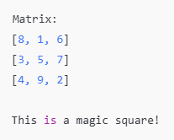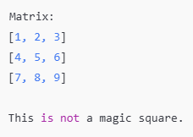Create a program to:  
1. Define a 2D array `matrix` of size NxM.  
2. Check whether the matrix is a **magic square** or not. A magic square is a square matrix where the sum of every row, column, and both diagonals is the same.  
3. Print the matrix and whether it is a magic square.  
  
Write a `main()` function to:   
1. Input a 3x3 matrix.  
2. Verify and display whether it is a magic square.